Guidelines for completing the Online Application for
Bilateral Workshops/Conferences/Training Programs

Before embarking on the application process, applicant(s) are advised to carefully go through the information available on the IUSSTF website for “Indo-U.S. Bilateral Workshops/Conferences/Training Programs”
(http://www.iusstf.org/story/53-17-Bilateral-Workshop--Symposium--Conference.html).

Step – 1: Online Registration
- The applicant(s) needs to register on the portal (https://www.ws.iusstf.org) for Bilateral Workshops/Conferences/Training Programs.
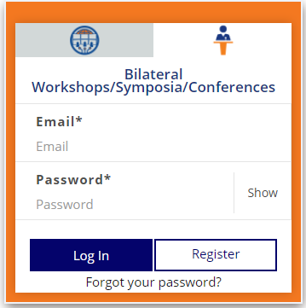
- The Registration contains essential details about the applicant and the Applicant’s registered email is the Login id.
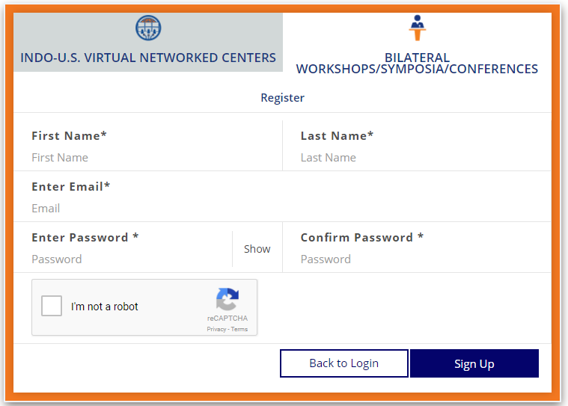
- Verify your account using the link sent to your registered email address. Please check your Spam/Junk folders in case the mails are not received in your inbox from program@iusstf.org.
- Please remember your user id and password for future reference.
- Forgot Password: In case you forget your account password, please click on ‘Forgot Password’ option on the login page. An email with the link to reset your password will be sent to your registered email ID. Please reset your password and login to your account.
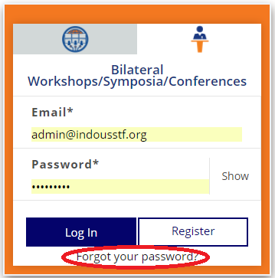
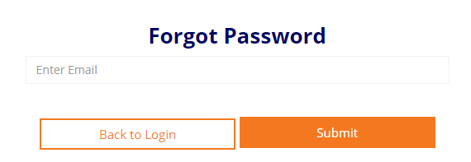
Things you should know about this application system:
- Please note that one lead partner (either U.S. or Indian) should create a login id and share it with the other counterpart(s) to enable them to fill the application.
- Navigation: You can get to any part of your application using the application navigation tool bar on the top of your screen. The application is optimized for Firefox, Chrome and Internet Explorer.
- All fields marked with a red asterisk * are mandatory. You will not be able to submit your application until all required forms and fields are completed.
- Click "SAVE" to save your application regularly. Do not navigate away from the page without clicking on "SAVE" at the bottom of each application section. Clicking "Back" or "Home" on your browser or any link on the application without saving it first will cause you to lose data on that page.
- Please note that the system assumes that you have finished answering a question if you have entered any text in the relevant box. Please make a personal note of incomplete items so that you can return to them at your convenience. Do not forget to review your application before you submit to ensure that you have completed the form as you intended.
STEP – 2: Submission of Application
This section contains personal details of the applicant(s), technical and financial details of the proposal and necessary uploads (in PDF format).
- All documents should be scanned and uploaded in PDF format only, strictly according to the list mentioned in the application form.
- Submission Process: Please complete the following sections:
  - Summary
  - Contact Information
  - Detailed Information
  - Budget Details
  - Reviewer(s) Details
  - Upload the Attachments
    - Letter from the Lead Indian Principal Investigator (s)
    - Brief CVs of Indian and US Principal Investigators
    - Brief CVs of Indian and US Co-Principal Investigators
    - Technical Program with Session Wise details and Name of Session Chair/Co-chair
    - Announcement Brochure (If available)

Once you complete the application, you will be asked to click on "Submit for Approval". The button will only be enabled once all requisite fields have been completed. After this, a mail will be sent out to lead partners in the application to approve the application form. Only after lead bilateral partners have approved the application form, will the Indo-U.S. Science and Technology Forum accept it for evaluation. If any of the partners rejects the application, you will be sent an intimation email and the application shall be available to you to edit again.
- Kindly ensure that your respective form is complete and filled to the best of your knowledge before clicking ‘Submit’.

STEP – 3: Approval of Application by Lead Partners
Kindly note that the application process will be considered complete only after bilateral lead partners approve the application. For approving the application, please follow these steps:
- Review the application using the links and credentials sent to bilateral lead partners by the online application system.
- Approve the submitted application by clicking the "Approve" button. This approval process must be completed by all partners before the application deadline.
- Once approved by both Lead Partners, the application will be considered submitted and will no longer be available for editing.
- The applicant(s) may download the PDF copy of the completed application after submission. The lead partners will receive an email acknowledgement regarding application submission. Please note the Application id for future reference.
Note:
- All documents should be scanned and uploaded in PDF format only, strictly according to the list mentioned in the application form.
- Please enter your personal details correctly as this would be used for all subsequent communication and documentation.
- Any change of address after submission of the application needs to be communicated to the respective program officer to ensure that no communication is missed out on.

If any applicant(s) is found to have furnished incorrect / misleading information at any stage, his/her application will be cancelled.
Hard copies of the submitted application are NOT REQUIRED. However, the candidate(s) are advised to keep the original copies of supporting documents (Endorsement letter, PI Certificate etc.) and a copy of the submitted application form for future reference.
IUSSTF reserves the right to change/modify the Application format/guidelines/FAQs at any time.

